**Homework 1**

**Due date: Mar. 12 Midnight**

***Note: Please note that the problems 1 – 3 below are from the 5th Edition of the text book “Computer Networking: A Top-Down Approach by Kurose and Ross”. If you do not have the textbook (or the 5th edition of the textbook), please refer to the file homework 1_addendum.pdf.***

1. Problem P16 on page 428 (20 pts).
2. Problem P24 on page 430 (20 pts).

|  |  |  |  |  |  |  |  |
| --- | --- | --- | --- | --- | --- | --- | --- |
|  |  |  |  |  |  |  |  |
|  |  |  |  |  |  |  |  |

1. Problem P26 on page 430 (20 pts).
2. Consider the network in the figure below. The numbers on links between the nodes represent the costs corresponding to these links (20 pts)

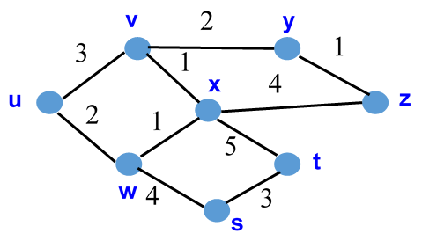

Compute the shortest path from u to all network nodes using Dijkstra’s

algorithm. Remember that D(r) represent the cost of the least-cost path

from u to r as of this iteration of the algorithm, p(r) is the predecessor of r

along the current least-cost path from u to r, N is the subset of nodes that

definitely belong to their least-cost path to u

1. Consider the subnetwork containing node {u, v, w, x, y, z} with same link costs as the network in the problem 4. Using the Distance-Vector algorithm, show the distance tables at node u. Assume that the algorithm works in a synchronous manner, where all nodes simultaneously receive distance vectors from their neighbors, compute their new distance vectors, and inform their neighbors if their distance vectors have changed. (The distance table at time 0 is given as follows.) 20 pts